

**Key Advantages of smart water management using IoT**

Water is the basic requirement for the survival of humans and it is the most global valuable commodity. A recent report exclaims that by the year 2025, nearly two billion people will be spending their lives in water scarcity areas. To avoid this issue, it is better to implement an intelligent water management system. Nowadays, most techies are focusing on the new [**Smart Water Management**](https://www.teamtweaks.com/blog/smart-water-management/)**using IoT**. IoT is a gigantic technology that processes a standard process for industrial units. The water sector coerces 100% attention to multiple resources in relevant amounts. The smart water techniques offer enhanced regulation over a water body, or wastewater treatment plant. The [**on-demand app development**](https://www.teamtweaks.com/on-demand-app-development)**companies** have started to focus on the IoT sector.

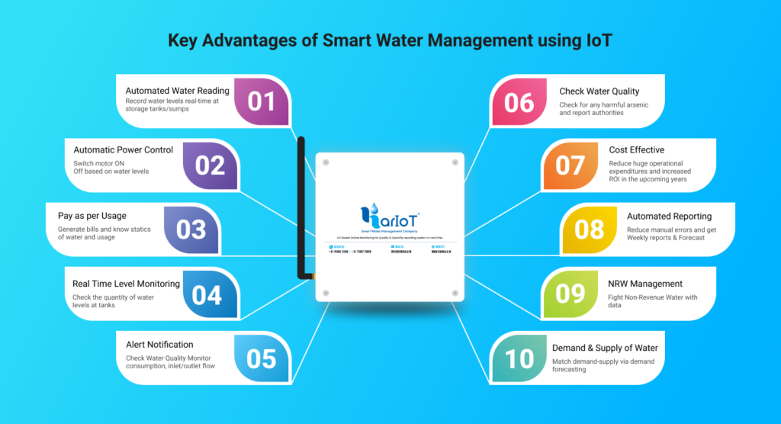

**Brief notes**

Internet of Things applies a series of proceedings & methodologies to satisfy the demands & needs with inadequacy in terms of quantity of water. The usage of sensors in industrial water areas advances the different sectors through real-time monitoring systems and instant alert systems. With the aid of IoT-driven scalable solutions, it is feasible to measure the level of misused water and & get immediate alerts when there is water leakage in the tank. Applying IoT techniques in the water system provides a series of advantages in the overall consumption pattern and provides efficient preservation of natural resources.

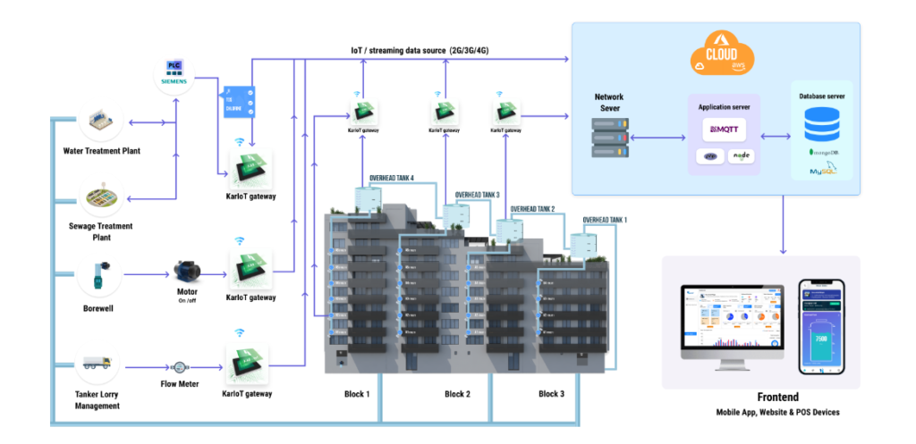

In the present era, IoT provides support for multiple industries which is subjective with smart water management solutions. These solutions preserve the overall maintenance and usage of resources. SCADA stands for Supervisory Control and Data Acquisition regulates water distribution systems. SCADA is installed within the overall system. By integrating [**smart water management using IoT**](https://www.karikala.in/) sensors, controlling leakage is feasible in real-time. A series of equipment like water sensors, IoT water flow meters, valves, and irrigation controllers track different measurements like water pressure, temperature, control of water, etc. The collective data of the IoT smart water management system helps multiple firms to analyze information related to real-time water resources. The IoT-enabled smart water management methodologies eradicate maintenance & operational cost.

**Working process of Smart Water Management**

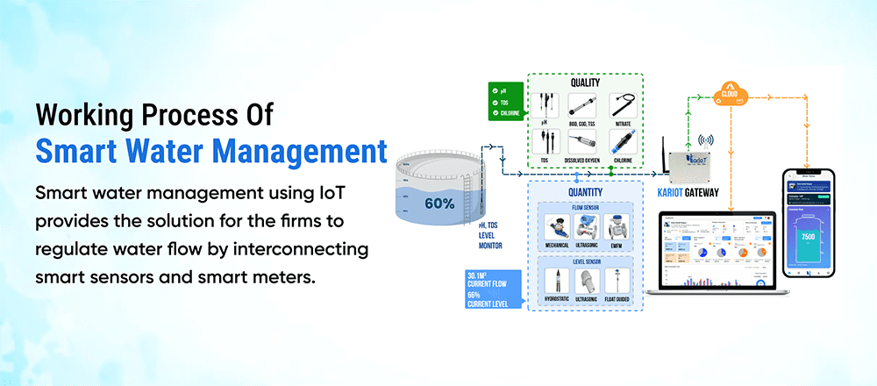

**Smart water management using IoT** provides the solution for the firms to regulate water flow by interconnecting smart sensors and smart meters. The main role of the sensors and meters is to collect water flow data and generate analytical water performance reports. With the aid of web dashboards, industries observe the utilization of water.

**What is the main objective?**

The main aim of Smart Water Management is to recycle water resources. The objectives are explained in detail.

**Eradication of wastage**

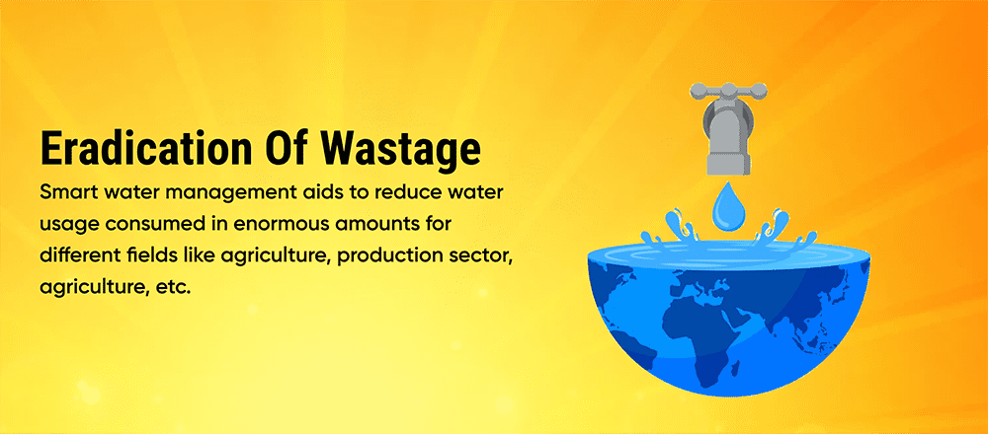

Smart water management aids to reduce water usage consumed in enormous amounts for different fields like agriculture, production sector, agriculture, etc. It contemplates the multiple practices of farming, agricultural applications, farming, etc. Mostly everyone has started to enforce agriculture software to process the tasks.

**Enhanced water quality**

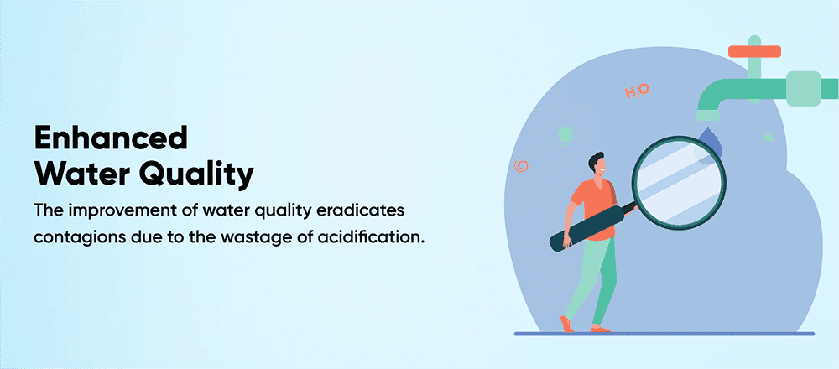

The improvement of water quality eradicates contagions due to the wastage of acidification. To enhance water quality, prominent industries are using trendier IoT techniques and sensors to regulate real-time monitoring.

**Optimizes efficiency factor**

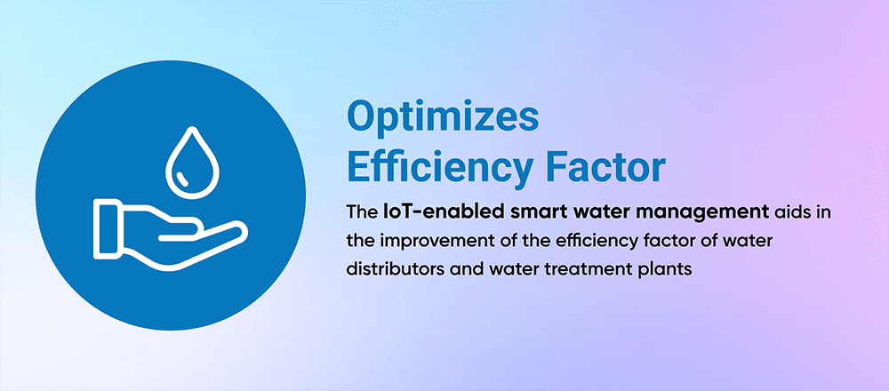

The IoT-enabled smart water management aids in the improvement of the efficiency factor of water distributors and water treatment plants. By developing robust solutions, multiple firms maintain different measurements like temperature, the flow of water, pressure, etc. The overall preservation helps to eradicate downtime & detriment of apparatus.

**Execution of leakage control**

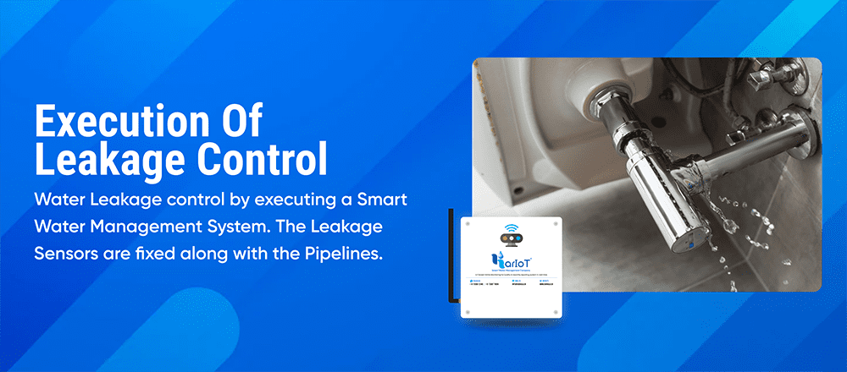

One can achieve water leakage control by executing a smart water management system. The leakage sensors are fixed along with the pipelines. A recent report estimates that nearly three billion dollars are needed to fix the impairment. The entire amount is calculated for about one year.

**Real-time monitoring**

The implementation of real-time monitoring in the field of IoT is a beneficial one. It completely preserves the water resources at different levels like households, industries, global locations, etc.

**Striking advantages**

There is a list of benefits of executing an IoT enabled Smart water management system. These benefits directly influence a series of factors like consumption, and conservation. We can discuss in detail different advantages one by one. One of the main benefits of smart water management is to increase the transparency factor. The collective data relies on stakeholders’ activities and supply chain. This one automatically results in the processing of decisions on how to increase operations. The IoT-driven scalable solutions enable authorities to automate the process and enhance human power. Well-defined water management systems possess the ability to detect bugs & respond instantly to eradicate damages. An automated data-driven approach translates data into typical savings. Next, sustainability is one of the important benefits for water industries. Smart water management plays a vital role in different fields like construction, energy production, etc.

The [**mobile app development**](https://www.teamtweaks.com/mobile-app-development-company-in-chennai) companies are focusing on the Smart water management fields.

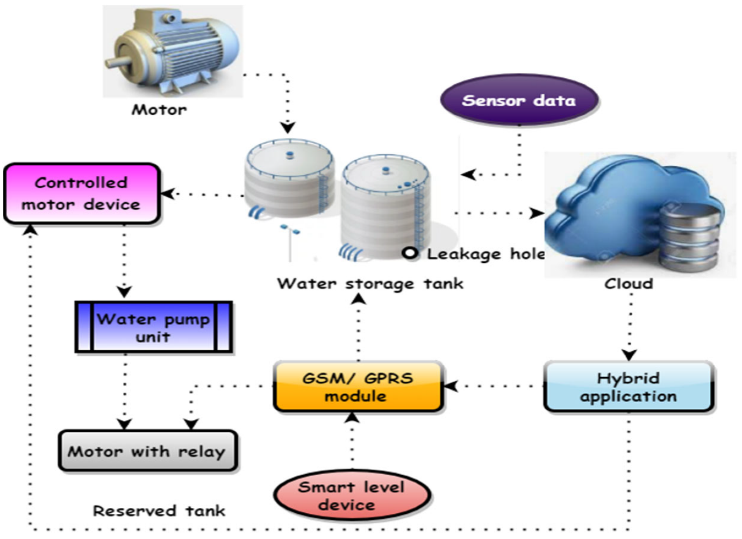Smart Water Management Using IoT

**Roles of IoT functionalities** **Water Conservation**

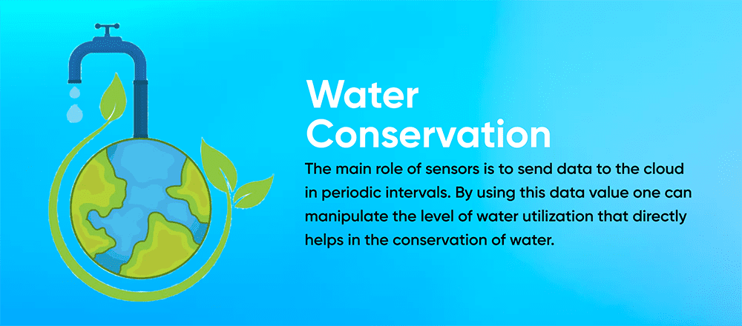

With the aid of IoT sensors, tracking water levels in the reservoirs is possible. The main role of sensors is to send data to the cloud in periodic intervals. By using this data value one can manipulate the level of water utilization that directly helps in the conservation of water.

**Smart Water Management**

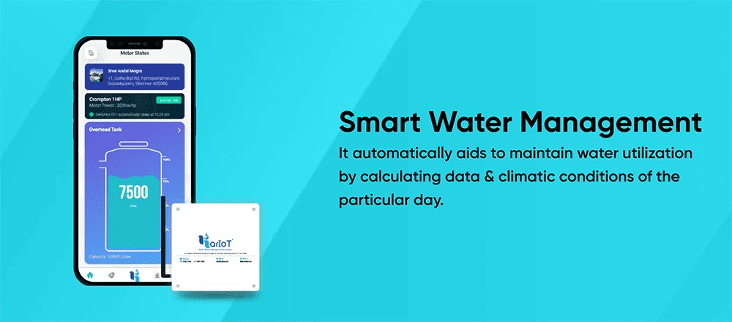

The preservation of water consumption is a challenging one for the management of water authorities. The Android app development company integrated with IoT technology regulates this overall concerned process. It automatically aids to maintain water utilization by calculating data & climatic conditions of the particular day.

**Wastewater Management**

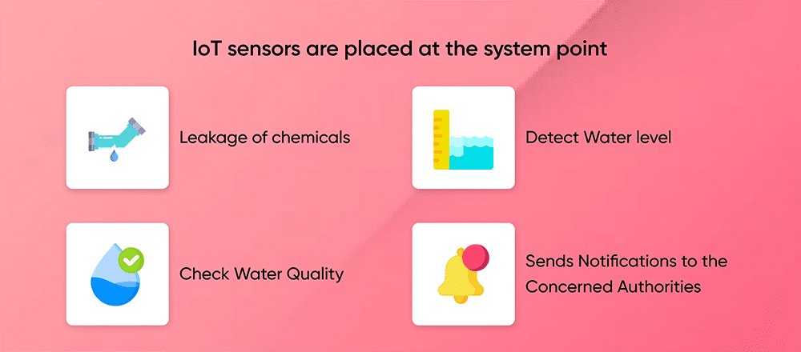

The main contradiction in [**water management**](https://www.karikala.in/) is the leakage of water and regulation of water through multiple channels. Initially, the IoT sensors are placed at the system point to detect water level, check water quality, leakage of chemicals, etc. It automatically sends notifications to the concerned authorities by sending data through the cloud system and solves the issue as soon as possible. An additional advantage of smart water management is to manipulate chemical issues in the water.

**Testing of water quality**

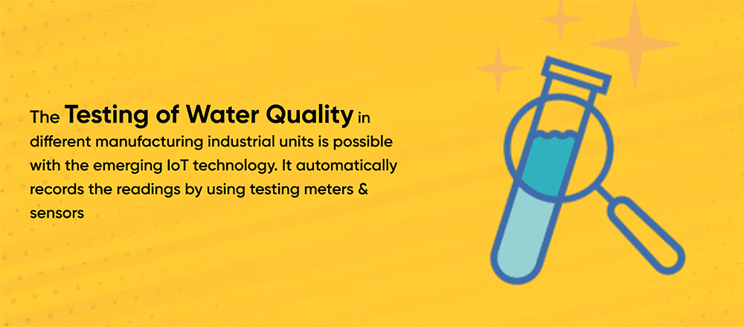

The testing of water quality in different manufacturing industrial units is possible with the emerging IoT technology. It automatically records the readings by using testing meters & sensors. Here, the collective information such as TDS, bacteria, and chlorine substances are sent to the cloud system for detailed analysis of the testing of water quality and solving the problematic locations. About ten to twenty years back, people were following older techniques for the conservation of water. As of now, IoT technology has bought advancements in every field and moved water conservation to a top-notch level. In this gigantic globe, there is a great demand for IoT solutions. These robust solutions play a vital role in the units of water resources and enhance water quality. Day by day planning of water resources is developing in this global industry.

**IoT-enabled Smart Water Management**

**Water level monitoring**

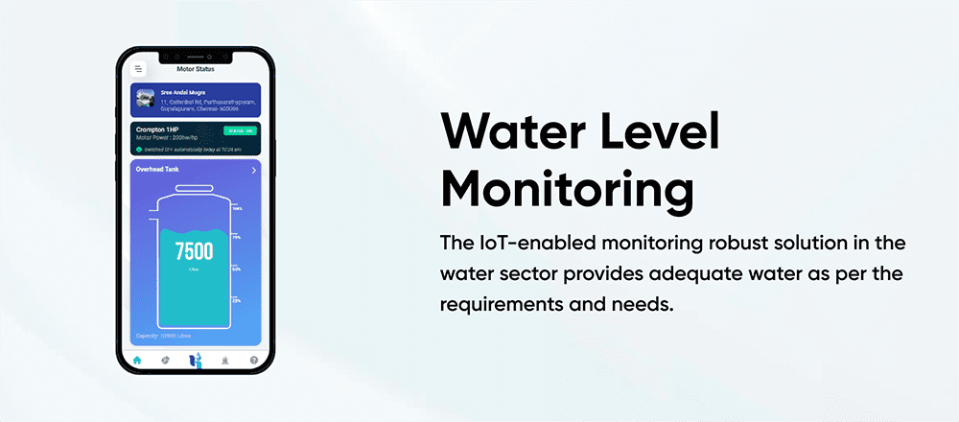

The [**IoT-enabled monitoring robust solution**](https://www.karikala.in/) in the water sector provides adequate water as per the requirements and needs. It possesses the ability to solve encumbrances and acquire top-notch results with the aid of a smart water management solution. The gigantic IoT trends & techniques target to deliver effective results that rely on the resources and utilizes resources, Machine Learning techniques, Artificial Intelligence protocols, analytics & other sets of proceedings that can enhance productivity factor.

**Sensors**

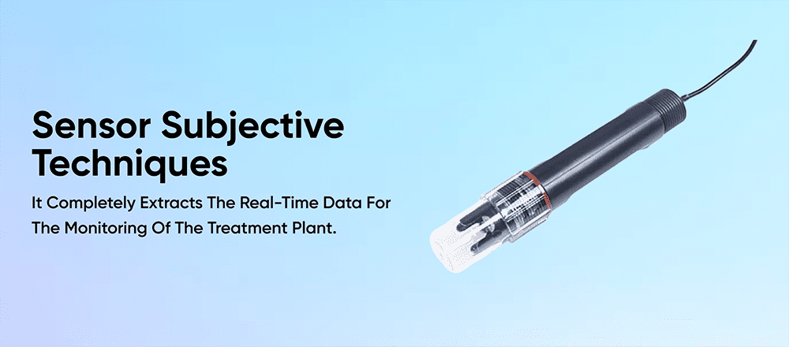

The IoT trends are based on sensor-enabled technology. On the sensor subjective techniques, nodes are integrated into the assets. It completely extracts the real-time data for the monitoring of the treatment plant. The water unit regulates an efficient way of processing for storage of water through sensor-driven methodologies. Nowadays, industries are occupying IoT-based techniques due to concerned needs in several locations. A series of sensor equipment and end-user services enhance the utilities.

**Wastewater Treatment**

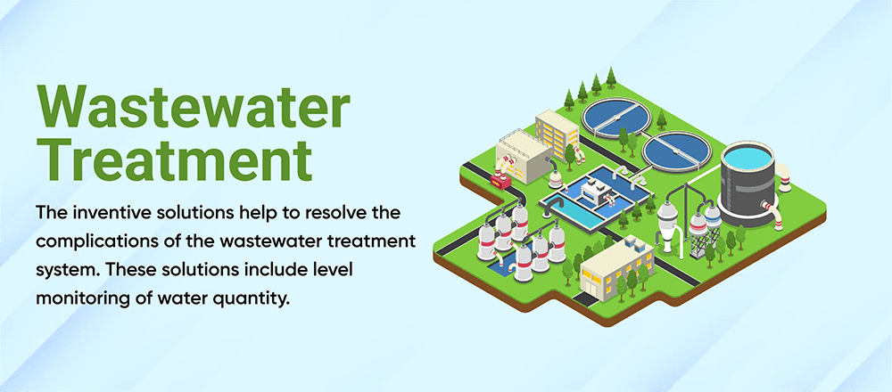

In this present era, IoT methodologies are securing the water sector. The inventive solutions help to resolve the complications of the wastewater treatment system. These solutions include level monitoring of water quantity. At the same time, it also aids in the calculation of origin value. Instant alerts will be sent to the user by interconnecting with their smart devices. At the same time, trends & technology provide efficient & quicker wastewater treatment and eradicate wastages due to leakages.

**Intelligent Irrigation System**

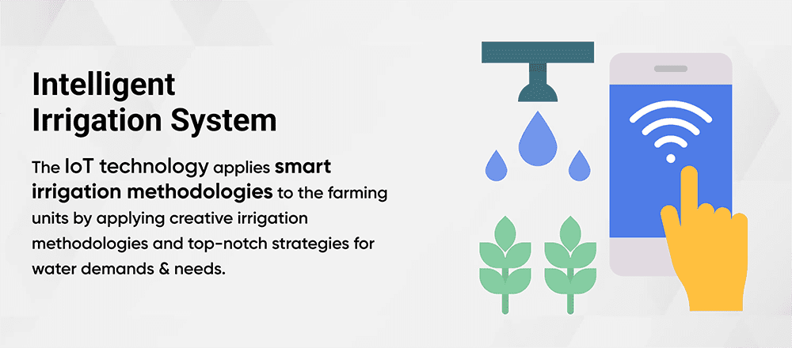

Generally, farming areas depend on utilized water for irrigation purposes. As of now, sensor-driven water meters play a vital role in agricultural areas without fear of losing outrageous water. The IoT technology applies smart irrigation methodologies to the farming units by applying creative irrigation methodologies and top-notch strategies for water demands & needs. The IoT-enabled water meters allow agriculturalists to set a concerning value beyond where the meter turns off. It is compatible with both Android and [**iOS app development**](https://www.teamtweaks.com/iphone-ios-app-development-company-in-chennai)**.** The farmers can save their precious time and apply remote monitoring techniques through the web.

Python Program for Connecting mobile app with Smart water management IOT project:

import 'package:flutter/material.dart';

import 'package:http/http.dart' as http;

import 'dart:convert';

void main() => runApp(MyApp());

class MyApp extends StatelessWidget {

@override

Widget build(BuildContext context) {

return MaterialApp(

home: WaterData(),

);

}

}

class WaterData extends StatefulWidget {

@override

_WaterDataState createState() => _WaterDataState();

}

class _WaterDataState extends State<WaterData> {

String waterData = "";

Future<void> fetchWaterData() async {

final response = await http.get('http://your-python-server-url/api/water-data');

if (response.statusCode == 200) {

setState(() {

waterData = json.decode(response.body).toString();

});

}

}

@override

Widget build(BuildContext context) {

return Scaffold(

appBar: AppBar(

title: Text('Water Data Monitoring'),

),

body: Center(

child: Column(

children: <Widget>[

ElevatedButton(

onPressed: fetchWaterData,

child: Text('Refresh Water Data'),

),

Text(waterData),

],

),

),

);

}

}

Testing and Debugging:

Thoroughly test the app to ensure that it correctly sends requests, handles responses, and updates the user interface.

Debug any issues with connectivity, data retrieval, or user interface updates.

Security Considerations:

Ensure that your server and app are secure. Use HTTPS to encrypt data transmission.

Implement authentication and authorization to restrict access to the app's features and data.

Deployment:

Deploy your mobile app to Android and iOS app stores or distribute it through enterprise channels, depending on your target audience.

Remember that real-world applications are typically more complex than this simplified example. They might involve multiple screens, data visualizations, and additional features. You should also consider scalability, error handling, and data synchronization for a production-ready app.

Connecting Mobile app with Smart water Management IOT Project:

To connect a mobile app to your Smart Water Management IoT project, you need to establish communication between the mobile app and the server where your IoT devices send data. This involves sending HTTP requests from the app to the server, retrieving the data, and displaying it in the app's user interface. Here's a step-by-step guide on how to achieve this:

1.Set Up a Server:

Ensure your Smart Water Management IoT project has a server that can receive and process data from IoT devices.

Implement APIs on the server to provide data to the mobile app. These APIs should handle incoming HTTP requests and return data in a format that the mobile app can understand (usually JSON).

2.Mobile App Development:

Use a mobile app development framework like Flutter or React Native to create your mobile app. In this guide, I'll use Flutter.

Create the app's user interface and layout, including buttons and widgets to display data.

3.HTTP Requests from Mobile App:

Use the http package (or equivalent) in Flutter to send HTTP requests to the server. For example, you can use the http.get method to request data.

In the app, when a user interacts with a button or refresh action, send an HTTP request to the server.

4.Handling Server Responses:

Once the server responds to the HTTP request, parse the JSON data received from the server. You can use the dart:convert library to decode JSON responses.

Update the app's user interface with the data received from the server.

Circiut diagram for Smart water management:

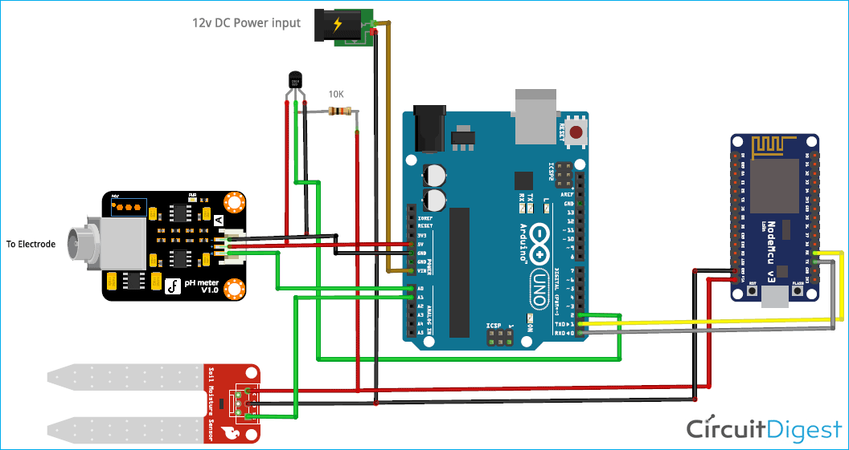

3-D Representation for Smart Water Management:

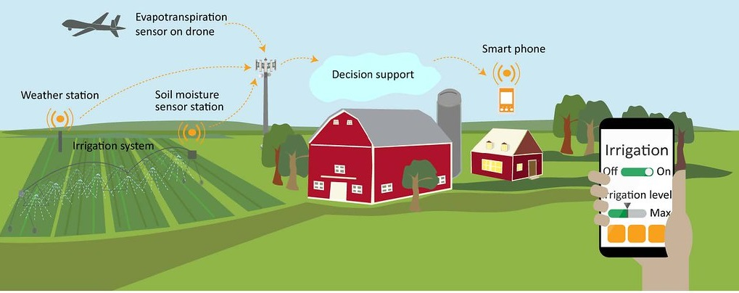

**Things used in this project**

**Hardware components**

* 1. **Sensors Used With Boltduino/Arduino**
     1. 5V Relay
     2. I2C LCD
     3. Boltduino
     4. 9V Battery
     5. Bolt Wifi Module
     6. IRF540 MOSFET
     7. Water Flow Sensor
     8. Ultrasonic Sensor X 2
     9. 1N4007 Rectifier Diode
     10. 12V DC Solenoid Valve
     11. Water Lifting Submersible Pump
     12. 4-way Capacitive Touch Switch Module
     13. 3-6 V Mini Micro Submersible Water Pump
     14. LM35 IC (Temperature sensor)
  2. **Sensors Used With Boltduino/Arduino**
     1. Nodemcu
     2. Piezo Buzzer
     3. IR Sensor X 2
     4. DC Motors X 2
     5. 12V DC Adapter
     6. TCS3200 Color Sensor
     7. Capacitive Touch Sensor
     8. ESP8266 Motor Driver Shield
     9. Analog Multiplexer IC – CD4051

**b) Software apps and online services**

* 1. Arduino IDE
  2. Bootstrap Studio
  3. Spyder (Anaconda)
  4. Twilio
  5. Canva
  6. Hostinger
  7. Integromat
  8. Mega Creator
  9. Pichon (Icons8)

**Smart water meters**

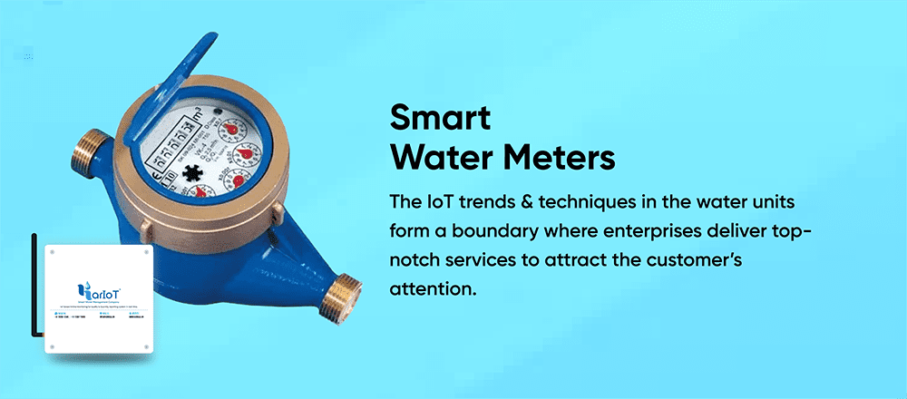

The utilities can wreck the causes of industrial production. Most firms utilize water in an enormous amount which drives an enhanced monitoring system that monitors water-enabled utilization patterns. With the aid of IoT-driven smart meters, companies depend on trustworthy sources & include enterprise sense that leads to optimized potentiality. The IoT trends & techniques in the water units form a boundary where enterprises deliver top-notch services to attract the customer’s attention. The smart meters provide a well-defined management system that preserves water at all phases.

**Final points!!**

In our conventional days, we don’t have any advancement in our infrastructure globally. But now everything has changed. We can plan for the modernized water utilities and their management, by adding IoT devices. The real-time time insight and its values can aid in the enhancement of productive factors. [**Smart water management**](https://www.karikala.in/)**using IoT**can preserve our water reservoirs. To get Quote for your project find some of the best[**IT Services Companies**](https://www.designrush.com/agency/it-services/north-carolina/raleigh) near you and hit start with your project